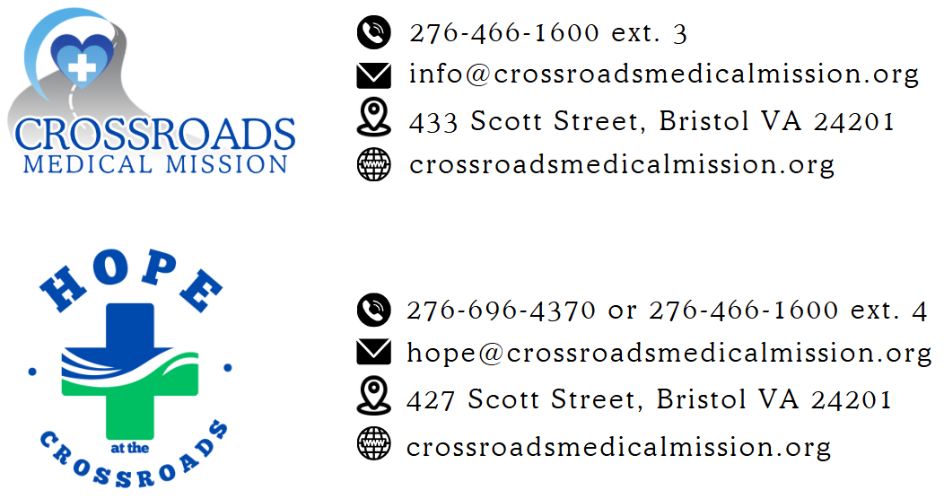
Adult Dental Resource List

Appalachian Highlands Community Dental Center 616 Campus Dr, Abingdon, VA 276-525-4487
A “safety net” dental clinic offering low-cost dental services for the uninsured in Southwest Virginia. For patients with limited opportunities for dental care. www.appalachianhighlandsdental.com

Appalachian Miles for Smiles Mobile Dental 1105 W. Stone Drive, Kingsport, TN 423-230-8888
Mission to Serve the Community with free Dental and Vision care. Remote Area Medical Events. Non-profit organization. Every Mile Improves a Smile! www.amfsmiles.org

Friends in Need Health Center – 1105 W. Stone Drive, Kingsport, TN 423-246-0010
Offers medical care, dental care, counseling, and assistance with prescriptions for the working uninsured & underinsured. Patients must live in a household with at least one working family member and fees are based on the total family income.

Healing Hands Health Center – 202 Memorial Drive, Bristol, TN 423-652-0260
Offers medical care, eye care, dental care, chiropractic care, counseling, and pastoral care for minimal charges. Serves those with no medical insurance in the greater Bristol area.

Keystone Dental Center – 603 Bert Street, Johnson City, TN 423-232-7919
Offers dental care for the uninsured in East TN. Charges are determined on a sliding scale based on income. Call for application information.

Mountain City Medical Center – 222 Oak Street, Mountain City, TN 423-727-6319
Offers dental care for the uninsured and insured. Charges are determined on a sliding scale based on income.

Sneedville Medical Center – 1861 Main Street, Sneedville, TN 423-733-2131
Offers dental care for the uninsured and insured. Charges are determined on a sliding scale based on income.

American Red Cross – 501 S. Wilcox Drive, Kingsport, TN 423-378-8700
Will pay for the extraction of one (1) abscessed tooth for uninsured Kingsport residents only. Call for application information.

Saltville Medical Center – 308 W. Main Street, Saltville, VA 276-496-4433
Offers dental care for the uninsured and insured. Charges are determined on a sliding fee scale based on income.

Washington County, VA Free Dental 276-645-5000
For persons established with the Social Services Department of Washington County, VA. Will do one extraction.
If a dental referral is made directly through Crossroads, these guidelines apply:
- Patient should be a resident of Bristol, Washington County VA or Sullivan County TN
- Patient must be able to physically lean back in a dental chair for approximately 1 hour for dental procedures.
- If patient has high blood pressure blood pressure needs to be addressed.
- Patient must not require Oxygen Therapy
- Patient must understand no pain medication stronger than Ibuprofen will be provided by dentist or CMM
- Patient must understand the dentist will only extract and fill damaged teeth. The number of teeth done is up to the dentist’s discretion. They may not pull all the teeth patient wants in one visit.
- Sedation will not be provided. Anesthesia cannot be provided.

Revised 02012024
/tmp/in/input.doc
Adult Medical Resource List

Crossroads Medical Mission 433 Scott St, Bristol, VA 276-466-1600
Provides medical care and can often help with testing, lab work, minor surgeries, and, in some instances, medication. Call for schedules and locations. www.crossroadsmedicalmission.com

Washington County Health Department 219 Princeton Rd, Johnson City, TN 423-975-2200
Offers primary care services on a sliding fee scale for patients using total household income falling within the parameters of the federal Poverty Guidelines.

ETSU Family Physicians of Bristol or Kingsport
Bristol- 208 Medical Park Boulevard, Bristol, TN 423-989-4050
Kingsport- 201 Cassel Drive, Kingsport, TN 423-245-9600
Offers medical care to the uninsured. The first visit requires a $100 payment before seeing the doctor. If able to pay the remaining balance after seeing the doctor, patients will be eligible for a 30% discount. If not, the patient is able to apply for the sliding fee scale. Must have proof of income.

Johnson City Community Health Center 2151 Century Lane, Johnson City, TN 423-926-2500
Offers free medical care for the uninsured and underinsured, TennCare enrollees, and the Hispanic population. No one is turned away because of the inability to pay.

Twin City Medical Center 2195 Euclid Avenue, Bristol, VA 276-669-5179
Provides medical care, mental health care, laboratory services, and minor surgeries for those patients that qualify for a sliding scale based on income and number in household.

Friends in Need Health Center 1105 W. Stone Drive, Kingsport, TN 276-466-0010
Offers medical care, dental care, counseling, and assistance with prescriptions for the working uninsured. Patients must live in a household with at least one working family member and fees are based on the total family income.

Healing Hands Health Center 202 Memorial Drive, Bristol, TN 423-652-0260
Offers medical care, eye care, dental care, chiropractic care, counseling, and pastoral care for minimal charges. Serves working uninsured (and their families) in the greater Bristol area.

Providence Medical Clinic of Kingsport 441 Clay Street, Kingsport, TN 423-247-4536
Offers free medical care to residents of Sullivan County and the city of Kingsport with an income at or below 120% of poverty guidelines. Eligibility determination: Tuesdays 10am-1pm. Clinic Thursdays at 6pm.

Rural Health Services Consortium
Bluff City Medical Center- 229 Highway 19-E, Bluff City, TN 423-538-5116
Kingsport Medical Center- 737 E. Sevier, Kingsport, TN 423-246-7922
Hawkins Medical Center- 4966 Highway 11-W, Rogersville, TN 423-272-5600
West Main Medical Center- 900 W. Main Street, Rogersville, TN 423-272-5202
Offers healthcare services on a sliding fee scale if total household income falls within certain parameters of the Federal Poverty Guidelines. Also accepts private insurance.

Appalachian Project Access 423-232-6700
Patients must have an urgent or emergent need and must be referred by a participating provider, whether primary, specialty, or hospital care. Patients are enrolled for 3-6 months, depending on need. www.projectaccesseasttn.org

Adult Behavioral Health Resource List

Frontier Health-Bristol 1145 Volunteer Parkway, Bristol TN 423-989-4500
Outpatient mental health, substance abuse, and co-occurring programs for adults, children, adolescents and families. Genoa Pharmacy on site. Services Provided: Individual Therapy, Family Therapy, Group Therapy, Case Management, Care Coordination, Crisis Services, Psychiatric Consultation, Pharmacotherapy, Peer Support Services, and Community Justice Services.
423-461-7050 Interpreting Services for Spanish Speaking patients
www.frontierhealth.org

Other FH Outpatient BH locations in Tri-Cities:
Watauga Behavioral Health 109 West Watauga Avenue, Johnson City, TN 423-232-2600
Holston Counseling 1570 Waverly Road, Kingsport, TN 423-224-1300
Johnson County Mental Health Clinic 318 Donnelly Street, Mtn City, TN 423-727-2100

FH Crisis Services:
Turning Point 208 E. Unaka Ave, Johnson City, TN 423-926-0940
CSU is a 24/7 voluntary program providing a safe and secure environment to those in need of psychiatric stabilization. Age 18 and over, 3-5 day stay, required Mobile Crisis eval

Detox Unit
Medically monitored detox unit serves adults over the age of 18 in need of detoxification from drugs and or alcohol. Residents transition to residential services (Magnolia Ridge Unit or Willow Ridge) or intensive outpatient services. Can self-refer
FH HOTLINES:
24/7 MOBILE CRISIS TN & VA: 877-928-9062
Domestic Violence Hotline: 844-578-7233

Highlands Community Services 610 Campus Drive, Abingdon, VA 276-525-1550
Outpatient MH and SUD services, developmental, psych, crisis, adult recovery, numerous C&Y, parenting, and peer services. Adult and Youth CMgmt, WRAP services, permanent supportive housing, psychosocial rehab, and pre-admission screenings. EMDR, Recovery Court, and Project Jane DV offered.

HCS Crisis Services:
The Anchor 276-525-1650 ext 2
This new program provides a 24/7 facility-based crisis center for individuals experiencing a psychiatric and/or substance-related crisis. It serves as an alternative to hospitalization where the crisis is expected to be resolved within 23 hours. Services offered include continuous observation and monitoring, crisis evaluation, brief intervention and de-escalation, referrals to wrap-around services, and coordination with community support.
HCS Hotlines:
M-F Crisis 8:30am to 5pm 276-525-1550 option 7
24/7 Crisis and Warmline 1-800-500-7019

State and National Prevention Hotlines:
Tennessee Statewide Crisis Hotline: 1-855-CRISIS-1 or 1-855-274-7471
Virginia Statewide Crisis Hotline: 1-888-903-3787
Mental Health Virginia Warm Line: 1-866-400-6428
National Suicide Prevention Hotline: 1-800-273-TALK or 1-800-273-8255
Veterans Crisis Line: 1-800-273-8255, press 1 or text 838255
National Domestic Violence Hotline: 1-800-799-7233
Crisis Text Line: text HOME or ASKUS to 741741

